Module 3. HTML

1. Are the HTML tags and elements the same thing?

Ans: HTML tags are used to hold the HTML element and html element holds the content. So, no html tags and elements are not the same thing.

2. What are tags and attributes in HTML?

Ans: HTML attributes are used to describe the

characteristic of an HTML element in detail and are

found only in starting of the tag.

HTML tags are used to hold the HTML element and

starts with < AND ends with >.

3. What are void elements in HTML? With Example.

Ans. Elements with no ending tags are known as

void elements.

The following is a complete list of the void elements in

HTML :

1)<br> 2)<embed>

4. What are HTML Entities? With Example.

Ans. An HTML entity is a piece of text ("string") that

begins with an ampersand ( & ) and ends with a

semicolon ( ; ). [One word statement]

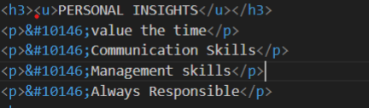

5. What are different types of lists in HTML? With Example.

Ans: There are 3 types of lists:

1)Ordered List:-

An ordered list starts with <ol>.

There are 5 Types od ordered list- 1)A 2)a 3)I 4)i

5)numbers[by default]

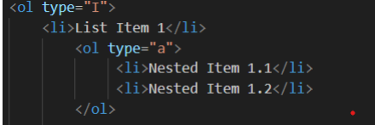

2)Unordered List:-

An Un ordered list starts with <ul>.

There are 3 types of un ordered list- 1)Circle 2) square

3)Disc[by default]

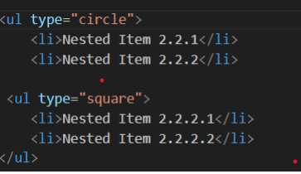

6. What is the ‘class’ attribute in HTML? With Example.

Ans. The class attribute is used to specify one or more class names for an HTML element. It is mainly used for styling and targeting elements with CSS

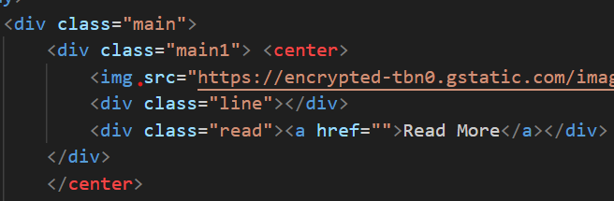

7. What is the difference between the ‘id’ attribute and the ‘class’ attribute of HTML elements? With Example.

Ans: A Class name can be used by multiple HTML elements, while an ID name must only be used by one HTML element within the page.

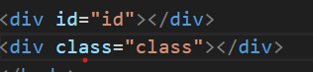

8. What are the various formatting tags in HTML?

Ans: Formatting tags are used to structure and style the content of web pages.

o <b> - Bold text

o <strong> - Important text

o <i> - Italic text

o <sub> - Subscript text

o <sup> - Superscript text

9. How is Cell Padding different from Cell Spacing? With Example.

Ans. Cell spacing re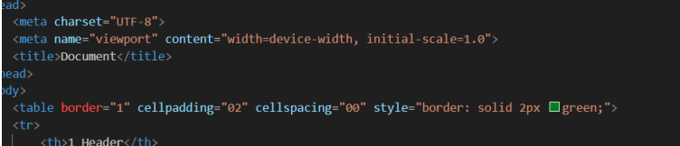fers to the distance between the

box where content is present, and cell padding refers to

the space around each box.

10. How can we club two or more rows or columns into a single row or column in an HTML table? With Example.

Ans. We can club two or more rows or columns

into a single row or column in an HTML table using

colspan and rowspan.

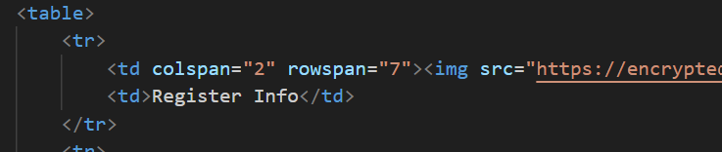

11. What is the difference between a block-level element and an inline element?

Ans: A block level element always has a break in

between in the content [start from new line].

An inline element doesn’t break the content [starts in

same line].

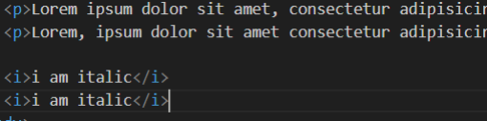

12. How to create a Hyperlink in HTML? With Example.

Ans: The HTML <a> tag defines a hyperlink. The most

important attribute of the <a> element is the href

attribute, which indicates the location of link.

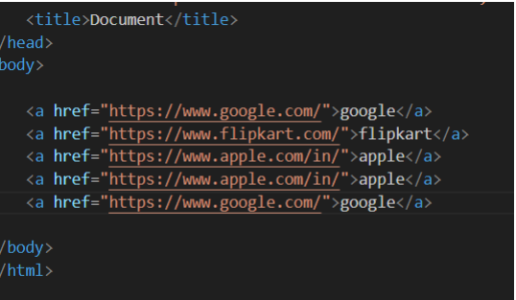

13. What is the use of an iframe tag? With Example.

Ans: <iframe> tag also an inline frame. <iframe> tag is

used for embedding others document in HTML

document.

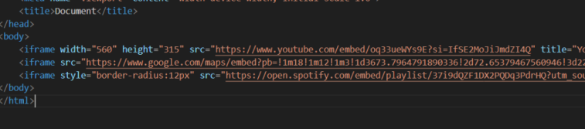

14. What is the use of a span tag? Explain with example?

Ans: This element is used to wrap sections of text for styling purposes or to add attributes to a section of text without creating a new line of content.

15. How to insert a picture into a background image of a web page? With Example.

Ans: To insert a picture into a background image of a web page, we can use CSS to style the background.

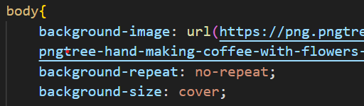

16. How are active links different from normal links?

Ans: An Active link is a hyperlink that is currently being

interacted with the user. Whenever the user holds the

mouse button on the link and not released yet or if

right clicked on it, it will change its color into red, this is

when the link will be in active state.

In HTML, an normal link is a hyperlink that is not yet

clicked by the user. By default, the unvisited links will

be in blue in color with an underline. However, we can

customize the style using the CSS properties

17. What are the different tags to separate sections of text?

Ans: There are three tags used to separate the texts.

Usually <br> tag is used to separate line of texts. Other

tags are<p> tag and <blockquote> tag

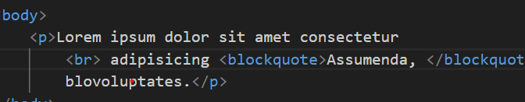

18. What is SVG?

Ans: SVG means Scalable Vector Graphics.

It is used for the web.

Each element and attribute in SVG files can be animated

19. What is difference between HTML and XHTML?  
Ans: HTML (Hypertext Markup Language) and XHTML (Extensible Hypertext Markup Language) are both markup languages used for creating web pages.

XHTML stands for Extensible HyperText Markup

Language

XHTML is a stricter, more XML-based version of HTML

XHTML is HTML defined as an XML application

XHTML is supported by all major browsers.

HTML is the Hypertext Markup Language which is the most

widely used language over the internet. HTML is used to

create web pages and link them from one to another. Please

note HTML is not a programming language, it is a markup

language. We can use different other technologies as like CSS

and javascript to give a new look to the pages developed by

HTML

20. What are logical and physical tags in HTML?

Ans: Logical Tags are used in HTML to display the

text according to the logical styles. Following are

the Logical tags commonly used in HTML.

<abbr> <address> <pre> <strong>

Physical Tags are used in HTML to provide actual

physical formatting to the text. Following are the

Physical tags commonly used in HTML.

<b> <i> <u>

21. Create below example using only HTML tags without CSS.

Ans: 